PHASE 5 – PROJECT DEVELOPMENT

5.1 Introduction
The project was developed using the ServiceNow platform. The main purpose of this phase is to implement the proposed system and automate the ticket management process using Flow Designer.

5.2 Creating the Ticket Record
A ticket record was created in ServiceNow with the required details such as short description, description, category, priority, state, and assignment group. This record is used as the input for the automation process.
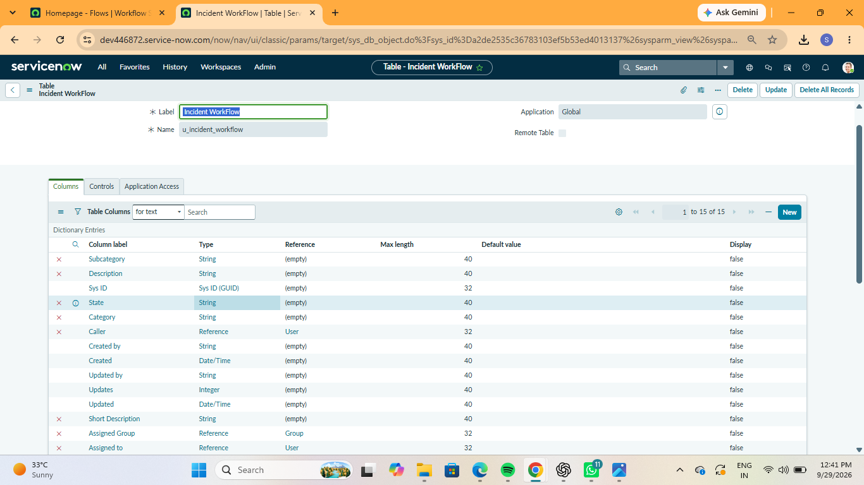
Figure 5.1: Creating a ticket record in ServiceNow

5.3 Creating the Flow
A flow was created using ServiceNow Flow Designer to automate the ticket management process. The flow contains a trigger, conditions, and actions that are executed automatically based on the ticket details.
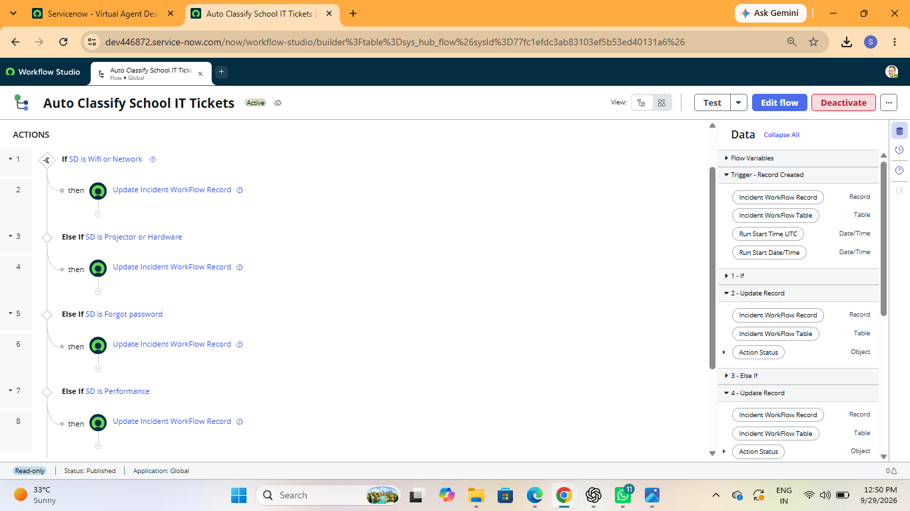
Figure 5.2: Automation flow created using Flow Designer

5.4 Configuring the Trigger
The trigger was configured to start the flow when the specified ticket condition is satisfied. This allows the system to automatically execute the flow without manual intervention.
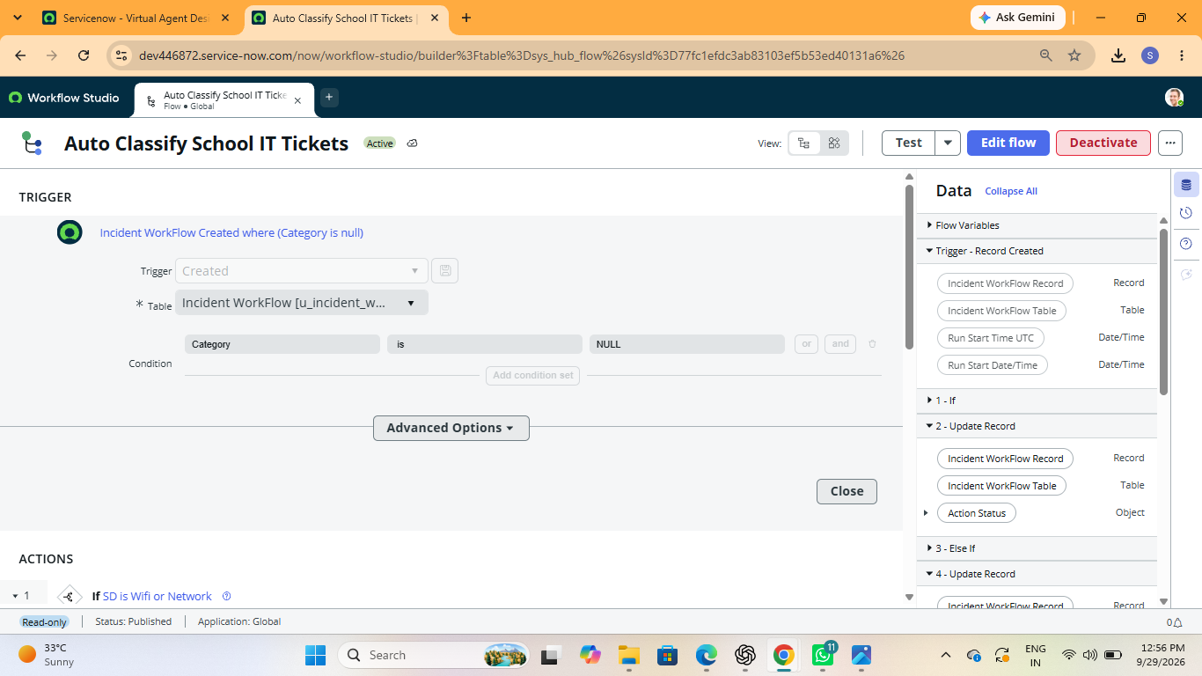
Figure 5.3: Configuring the flow trigger

5.5 Configuring Conditions
Conditions were configured in the flow to identify the required ticket information and determine the appropriate processing steps.
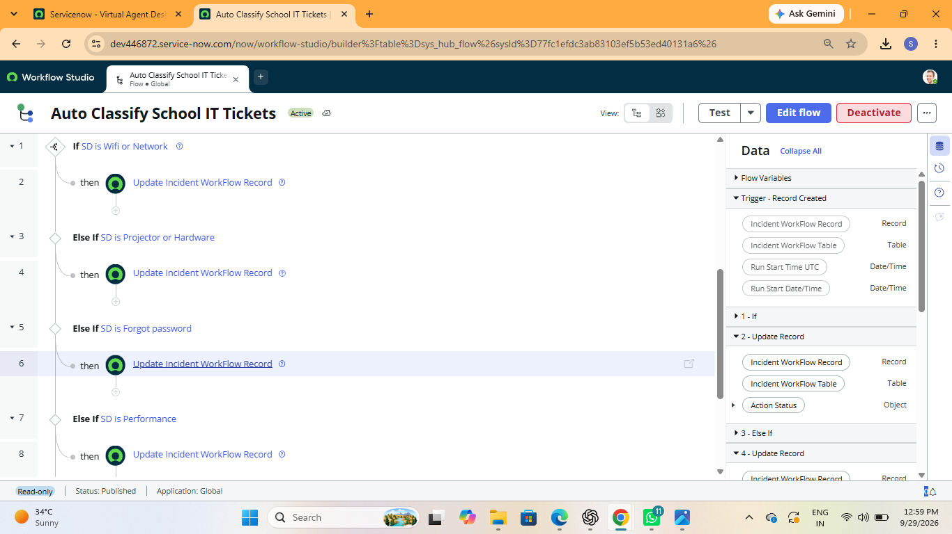
Figure 5.4: Configuring conditions for ticket processing

5.6 Configuring Actions
The required actions were configured in Flow Designer to process the ticket automatically. These actions perform the required updates or other operations based on the configured conditions.
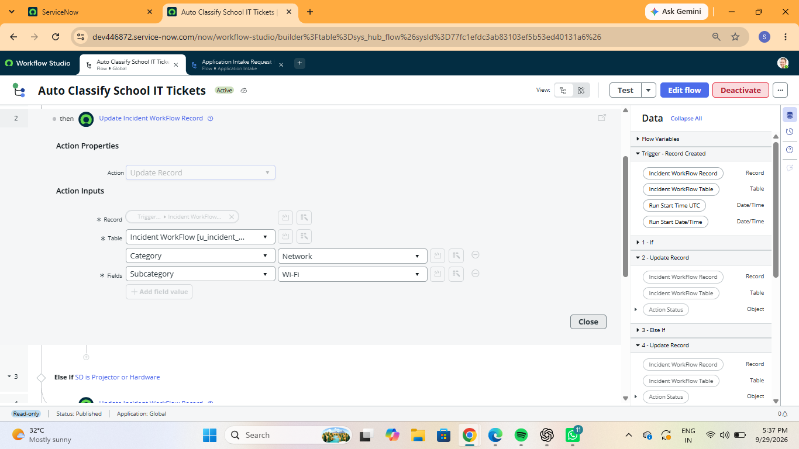
Figure 5.5: Configuring actions in the flow
5.7 Testing the Flow

After completing the flow configuration, the flow was tested using a sample ticket record. The test was performed to verify whether the trigger, conditions, and actions were working correctly.
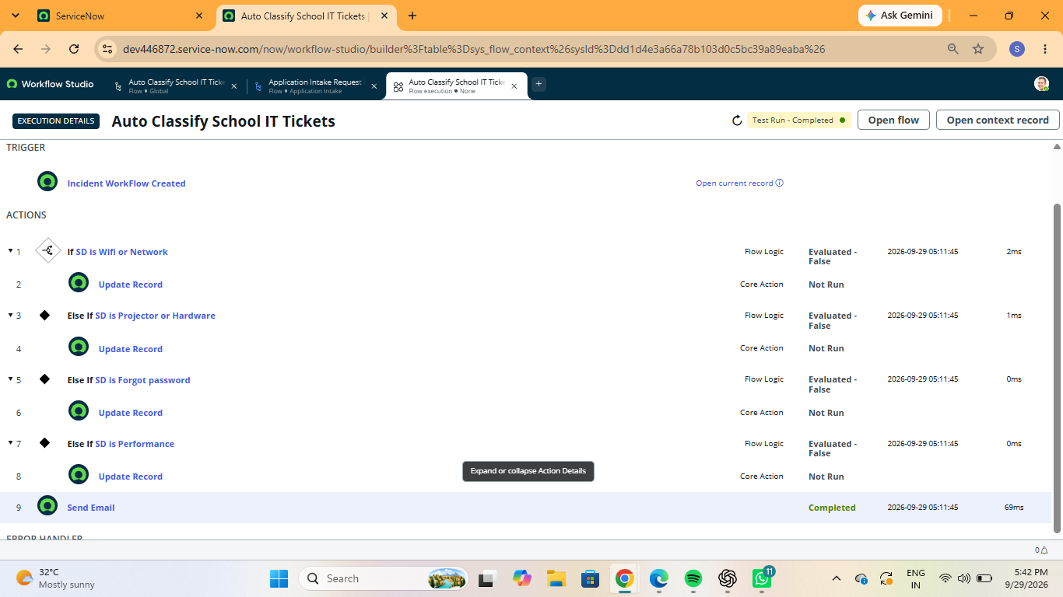
Figure 5.6: Testing the automation flow

5.8 Verifying the Output

The ticket record was verified after the flow execution. The required changes were checked to confirm that the automation worked as expected.
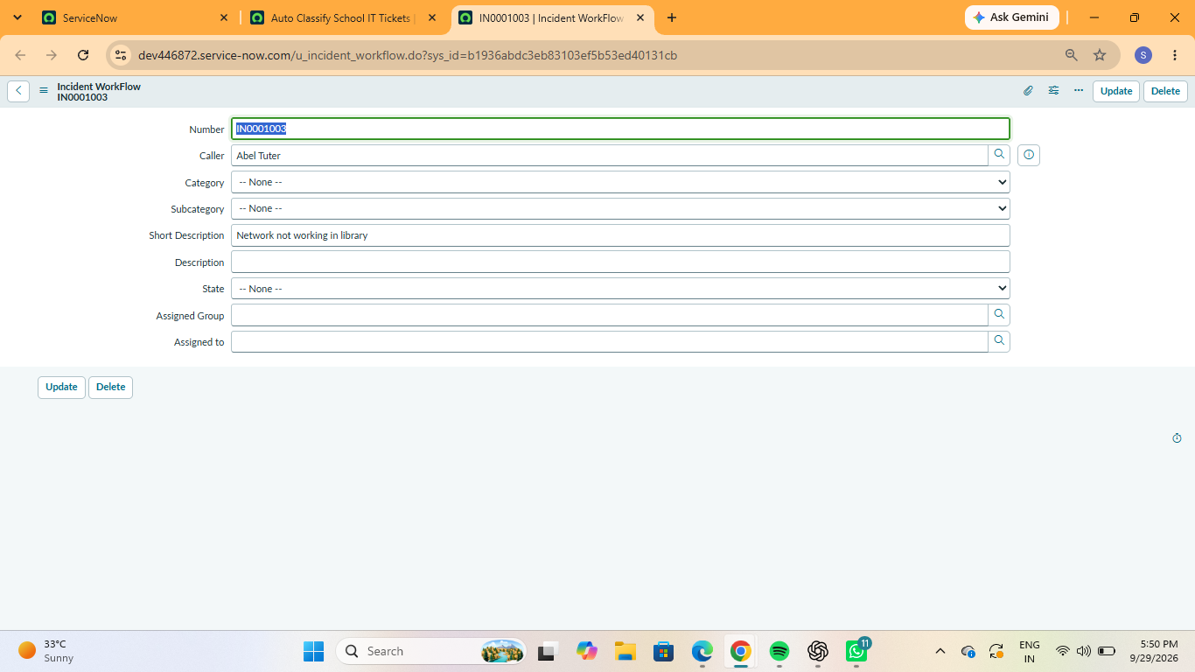
Figure 5.7: Verifying the automated ticket update

5.9 Development Outcome
The development phase successfully implemented the proposed ticket automation process in ServiceNow. The configured flow can automatically process the ticket based on the defined trigger, conditions, and actions. This reduces manual effort and improves the efficiency of ticket management.

